**CURRICULUM VITAE**

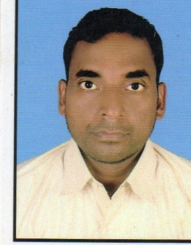TEJNARAYAN SAW

VILL-GOPALDIHPOST –BEKO

PS-BAGODARDIST-GIRIDIH

DIST-JHARKHAND

EMAIL [ID-narayansaw2016@gmail.com](mailto:ID-narayansaw2016@gmail.com)

Mob no -9955397019/9507604262

**CAREER OBJECTIVE:-**

To be a part of highly esteemed company. Looking for opportunity to expand my current skill base and be presented with opportunities to grow with the company.

**ACADEMIC BACKGROUND:-**

*Passed Senior Secondary Exam(I.S.C) from R.V.S Collage Bokaro Steel City.

*Passed Higher SeconderyExam(B.S.E.B)From S.S.K.B High school Dumari.

___________________________________________________________________**PROFESSIONAL QULIFICATION:-**

*B.C.A (Bachelor in computer application)from I.G.N.O.U New delhi(RESULT WATING).

*2year eDAST(eDipolma in Advance Software Technology)from C.M.C LTD(A joint venture of Govt of india&Tata sons).

**WORKING EXP.**

___________________________________________________________________**NAME OF THE EMP NAME OF LINE WORKING PERIOD DESIGNATION**

**1.TATA PORJECT**400KV LINE FROM 2007-09 SUPERVISOR

DARJILING TO SILIGURI

___________________________________________________________________

**2. TATA PROJECT** SHIVNI TO KHANDWA 2009-13 SUPERVISOR

765 KV D/C LINE VINDYACHAL

TO CHAMRADOL

**3. EMCO LTD** 800 KV HVDC LINEOct.2013 TO 15 SUPERVISOR

BISWNATH CHHERIY TO

AGRA

**4. KEC INTERNATIONAL** 800KV HVDC LINE 2015 TO 2018 SUPERVISOR . **LTD**CHAMPA TO KURUKSHETRA

LINE (PGCIL)

**5.BSNL** OUTSOURCING JUNE-18 TO JUNE-2019 RIDER

**6.DILIP BUILDCON LIMITED** JULY-2019 TO 23 DEO

**(CENTRAL ZONE)**

**CURENT SELFs CSC KHUSHI DIGITAL 2024**

**PERSONEL DETAILS:-**

* D.O.B :- 21-05-1980
* FATHER’S NAME :- DEGLAL SAW
* MARITAL STATUS :- MARRIED

**DECLARATION**:-

* I hereby declare that the above written particulars are true to the best of my knowledge and belief.

18-01-20 20 TEJNARAYAN SAW