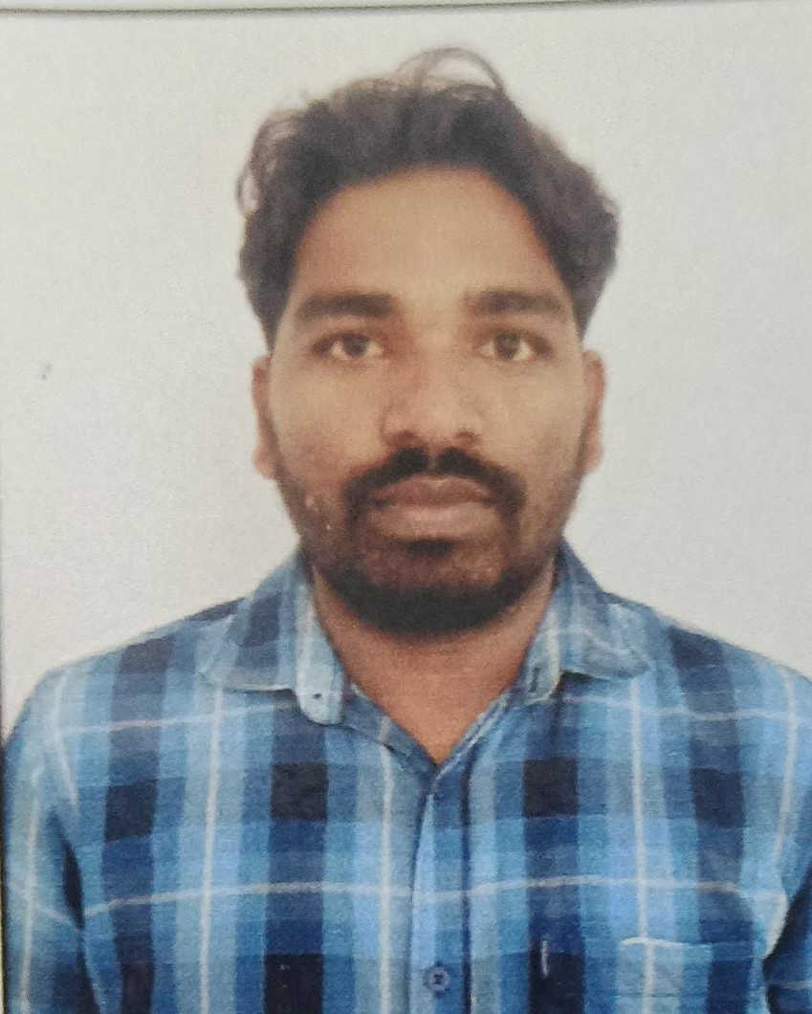
Photo
RESUME
NAME :- VIVEK RAJ
FATHER`S NAME :- PANDIT MANDAL
MOTHER`S NAME :- RAWRI DEVI
PRESENT ADDRESS :- AT- KHAIRABANDH, P.O. -BARGO,
DIST – DUMKA (JHARKHAND) , PIN CODE :- 814120
DATE OF BARTH :- 14/01/1996
SEX :- MALE
MARITAL STATUS :- MARRIED
CATEGORY :- OBC
NATIONALITY :- INDIAN
LANGUAGE :- HINDI/ ENGLISH
UID NUMBER :- 462361368946
MOBILE NO :- 7319845463

EDUCATION QUALIFICATION :-
S.N | EXAM PASSED | PASSING YEAR | NAME OF BOARD/UNIVERSITY | DIV | %
1 | MATRIC | 2011 | JAC RANCHI | 1 nd | 62%
2 | INTER | 2018 | JAC RANCHI | 2 nd | 58.8%
3 | DIPLOMA | 2014 | SBTE RANCHI | 1 st | 69.25%

EXTRA QUALIFICATION :- COMPUTER (BCC )
EXPERIENCE :- 3 YEARS (PRAWAH NGO)FIELD WORK,SHG,AGRICULTURE,7 YEARS(VLE)

DATE:-14/12/2024 SIGNATURE

